**JENKINS ASSIGNMENT**

1. **Build and Deploy a Simple App using Jenkins**

**Step 1: Install Required Plugins**

1️. Open **Jenkins Dashboard** → **Manage Jenkins** → **Manage Plugins**.  
2️. Install the following plugins:

* **Pipeline**
* **Git Plugin**
* **Docker Pipeline Plugin** (if using Docker)

**Step 2: Create a New Jenkins Pipeline Job**

1️. In Jenkins, click **New Item** → **Pipeline** → Give it a name → Click **OK**.  
2️. Scroll down to the **Pipeline** section and select **Pipeline script from SCM**.  
3️. In the **SCM** field, select **Git**, then enter your **GitHub repository URL**.  
4️. In the **Branch Specifier**, enter */main or */master.  
5️. In the **Script Path**, enter Jenkinsfile (which we will create in the next step).

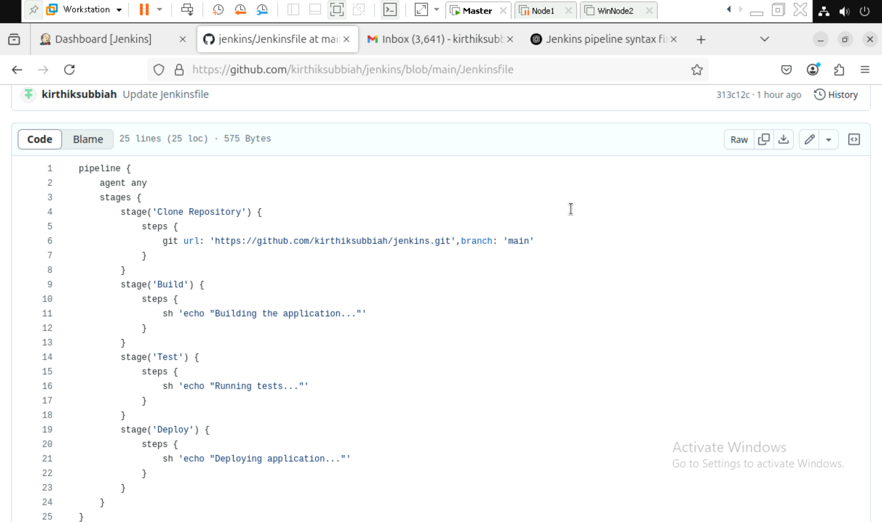

Build History:

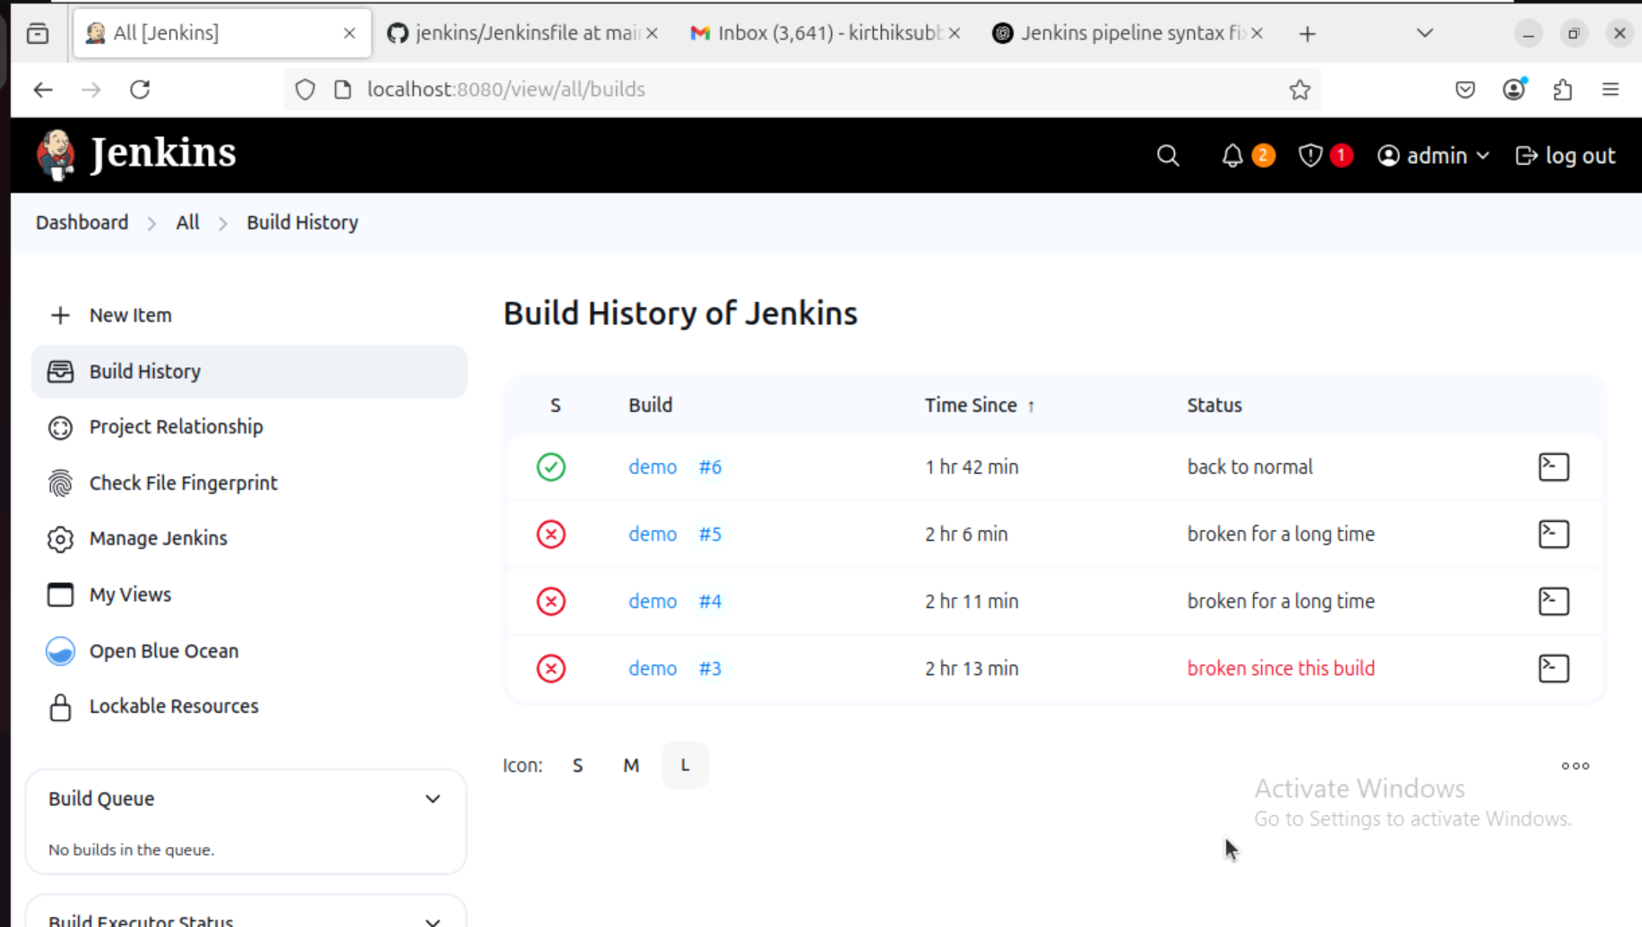

Status of Each stages of the pipeline:

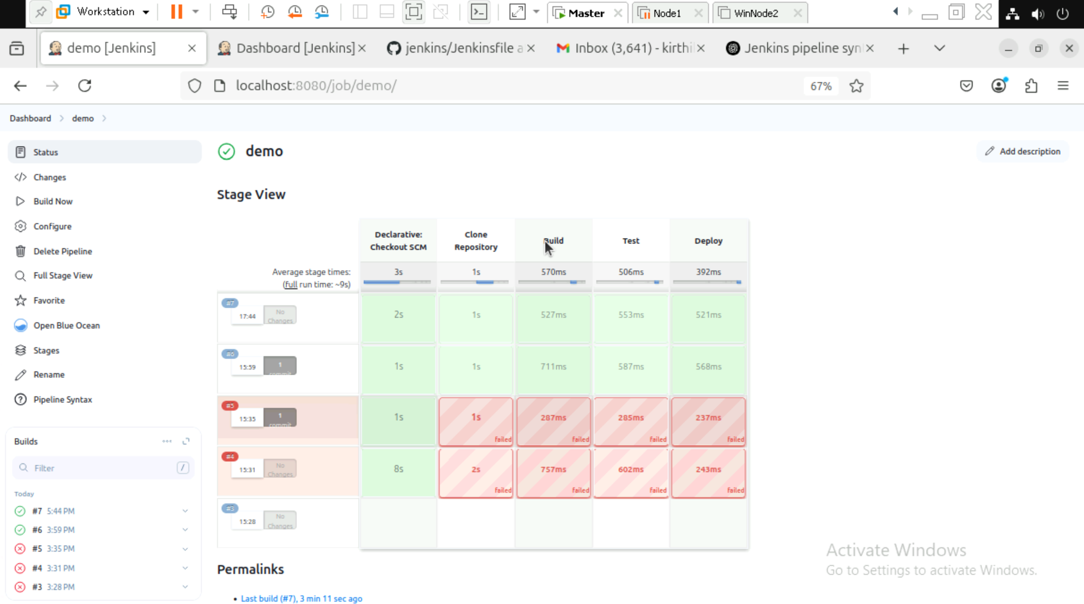

Workspace:

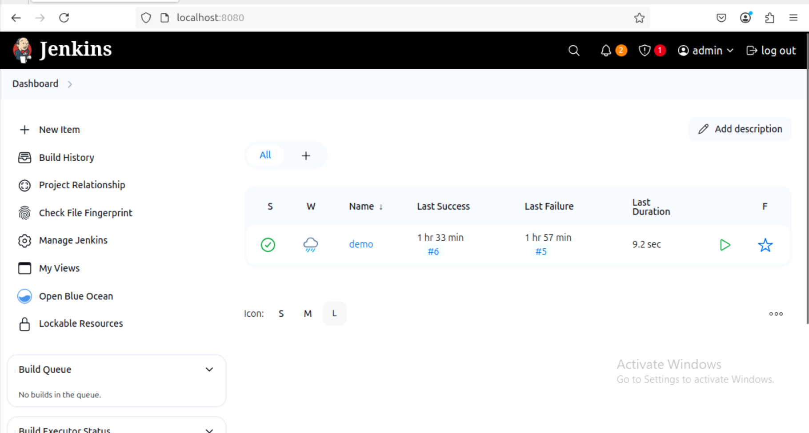

Status of the Pipeline:

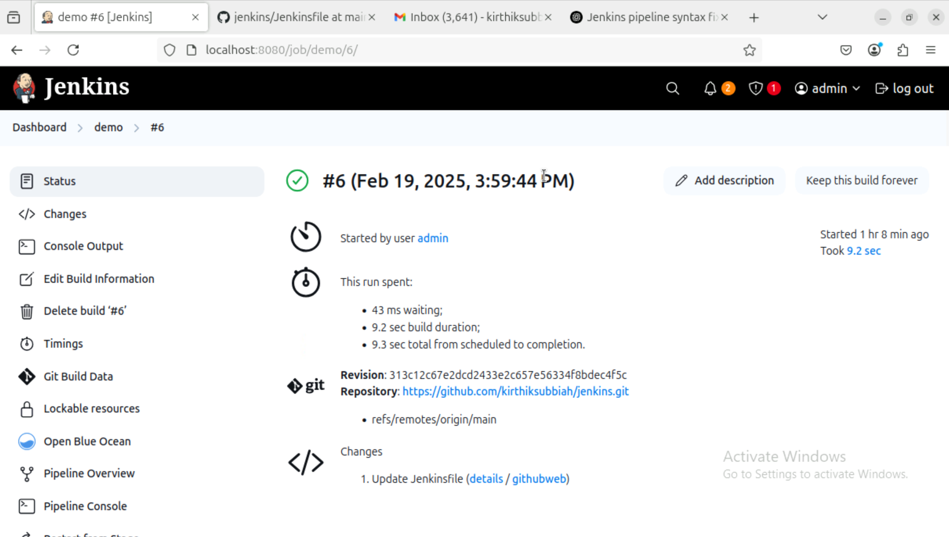

**Step 3: Create a Jenkinsfile (CI/CD Pipeline)**

In your GitHub repository, create a new file named **Jenkinsfile** and add the following code:

groovy

CopyEdit

pipeline {

agent any

stages {

stage('Clone Repository') {

steps {

git 'https://github.com/your-username/your-repo.git'

}

}

stage('Build') {

steps {

sh 'echo "Building the application..."'

}

}

stage('Test') {

steps {

sh 'echo "Running tests..."'

}

}

stage('Deploy') {

steps {

sh 'echo "Deploying application..."'

}

}

}

}

**Explanation:**

* **Stage 1: Clone Repository** → Pulls the latest code from GitHub.
* **Stage 2: Build** → Builds the application (placeholder command).
* **Stage 3: Test** → Runs tests (placeholder command).
* **Stage 4: Deploy** → Deploys the app (placeholder command).

**Step 4: Build and Run the Pipeline**

1️. Go back to **Jenkins Dashboard** → Click on your job.  
2️. Click **Build Now**.  
3️. Click **Console Output** to see the progress.

If everything is successful, you will see all **stages completed** in the output.

**Step 5: Deploy with Docker (Optional)**

If you want to deploy your application as a **Docker container**, modify your **Jenkinsfile** like this:

groovy

CopyEdit

pipeline {

agent any

environment {

IMAGE_NAME = 'your-dockerhub-username/my-app'

}

stages {

stage('Clone Repository') {

steps {

git 'https://github.com/your-username/your-repo.git'

}

}

stage('Build Docker Image') {

steps {

sh 'docker build -t $IMAGE_NAME .'

}

}

stage('Push Docker Image') {

steps {

withDockerRegistry([credentialsId: 'docker-hub-credentials']) {

sh 'docker push $IMAGE_NAME'

}

}

}

stage('Deploy') {

steps {

sh 'docker run -d -p 8080:80 $IMAGE_NAME'

}

}

}

}

**Explanation:**

* **Builds a Docker image** of your application.
* **Pushes it to Docker Hub** (requires credentials setup in Jenkins).
* **Deploys the container** on a local machine or server.
* You have successfully set up **Jenkins CI/CD** to **build, test, and deploy** a simple app!
* If using **Docker**, your app is now running on **http://localhost:8080**.

1. **Automating a Python Application Build using Jenkins.**

**Step 1: Install Jenkins and Required Plugins**

1. Start the Jenkins service and log in to the Jenkins dashboard.
2. Navigate to Manage Jenkins → Plugins.
3. Install the following plugins:
   * Pipeline Plugin (for defining Jenkins Pipelines)
   * Git Plugin (for pulling code from GitHub)
   * Build Tools Plugin (for executing builds)
4. Restart Jenkins to apply the changes.

**Step 2: Create a New Jenkins Job**

1. Open **Jenkins Dashboard**.
2. Click on **New Item** → Enter a project name.
3. Choose **Freestyle Project** or **Pipeline Project**.
4. Click **OK** to create the project.

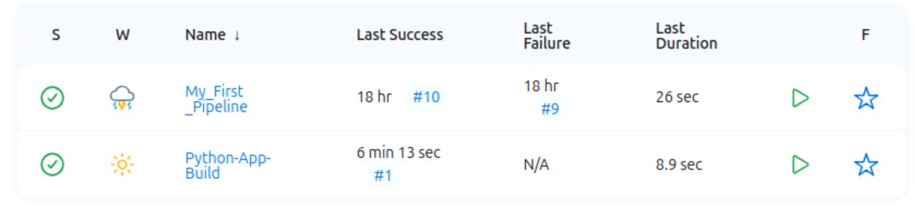

**Step 3: Configure Jenkins to Pull Code from GitHub**

1. Open the newly created Jenkins job.
2. Navigate to **Source Code Management**.
3. Select **Git** and enter the repository URL:
   * Example: https://github.com/your-repo/python-app.git
4. Configure GitHub credentials if authentication is required.

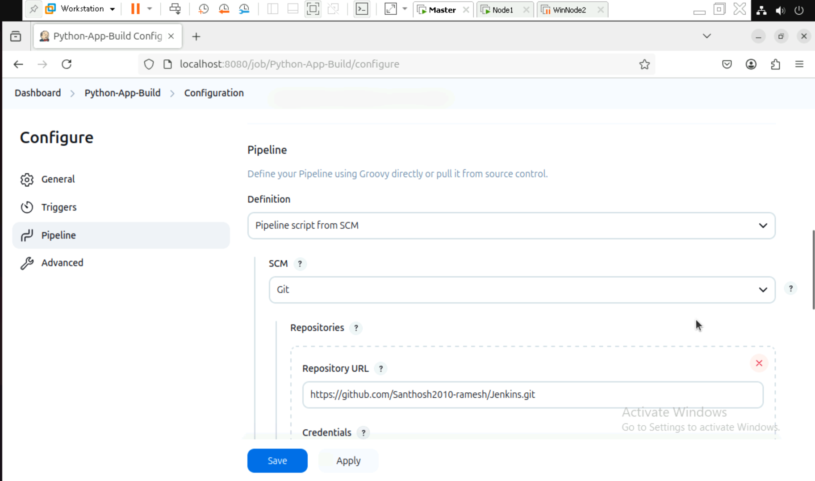

**Step 4: Install Dependencies and Run Tests**

Step 1: Adding the desired branch here we use Main branch.

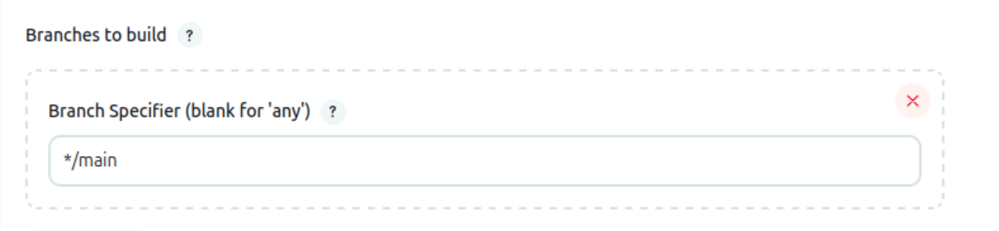

**Step 5: Pipeline with Python Scripts.**

**Step 1: Building the Declarative: Checkout SCM with the Script.**

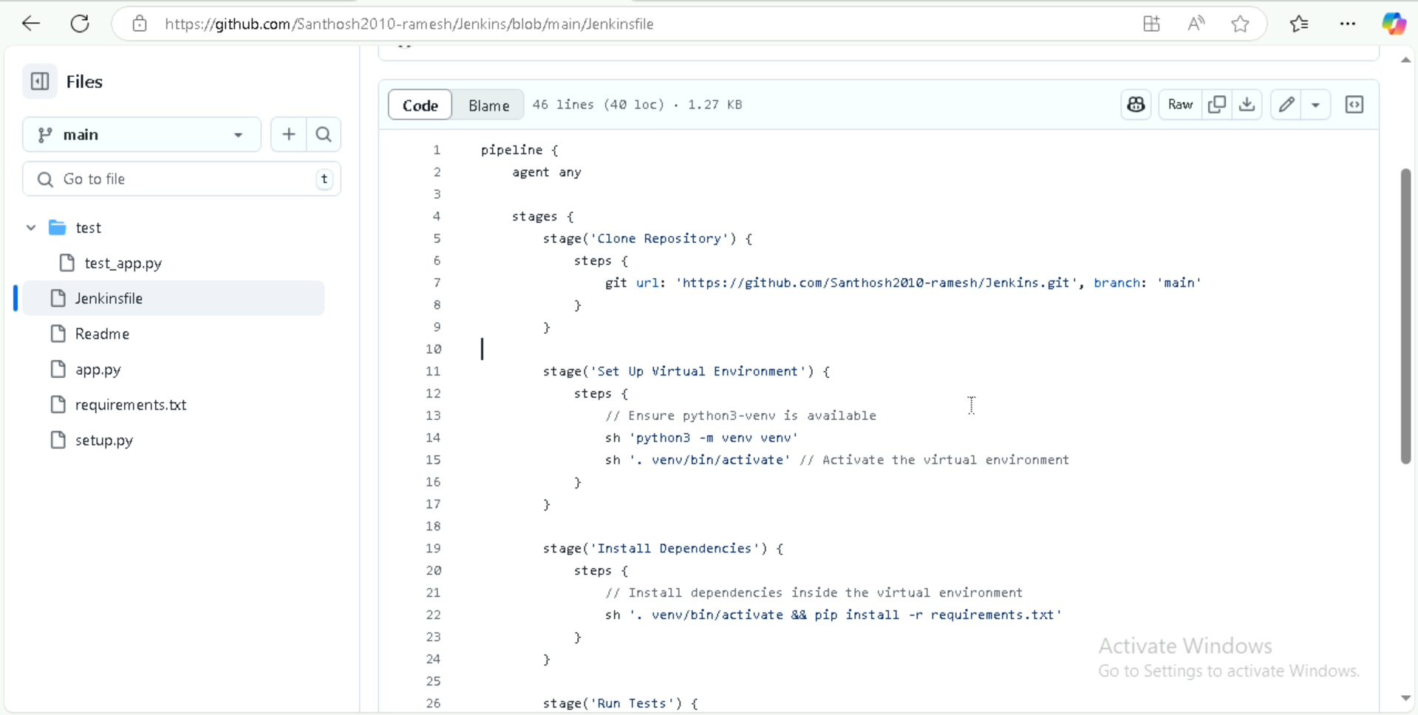

**Step 2: Sample Python file.**

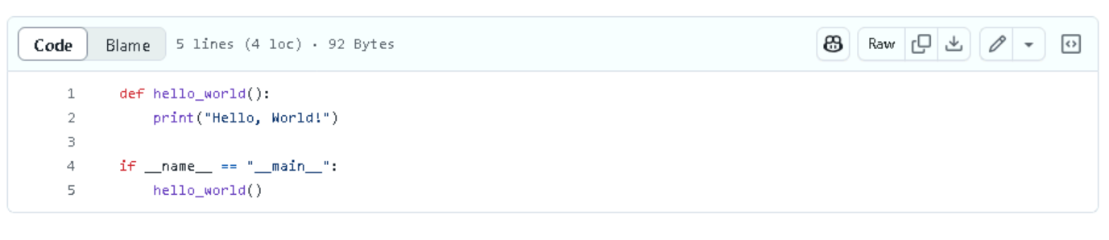

**Step 3: Creating Requirements.txt file.**

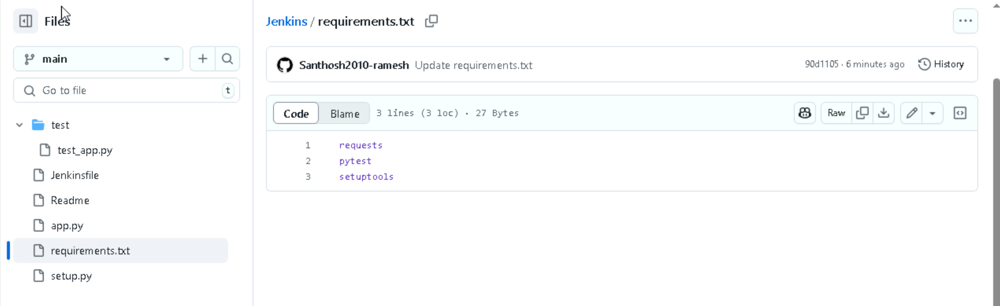

**Step 4: Creating a Setup.py file.**

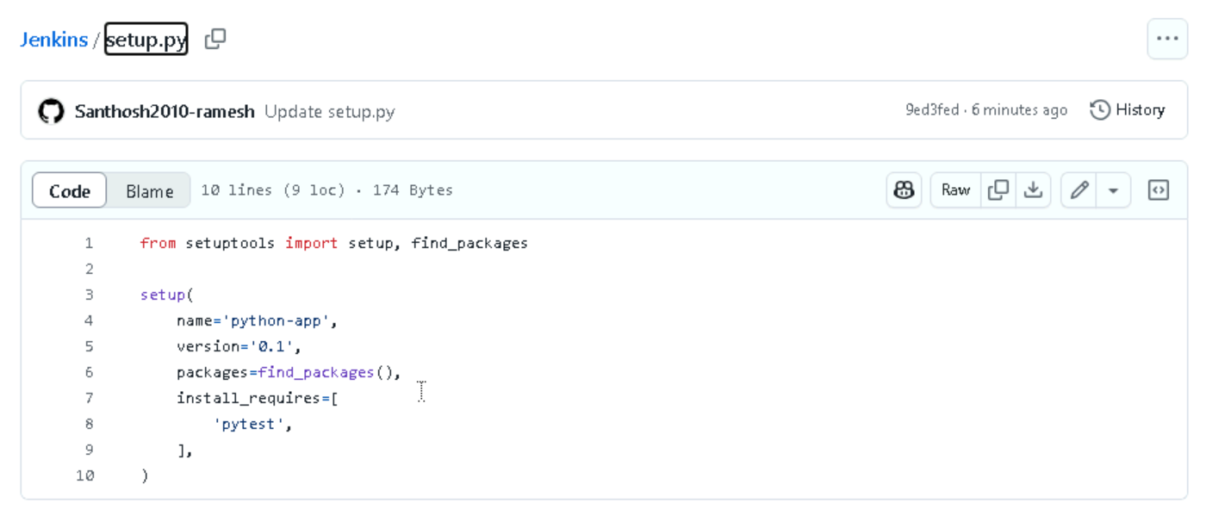

**Step 5: Creating a sample test.py for checkrun.**

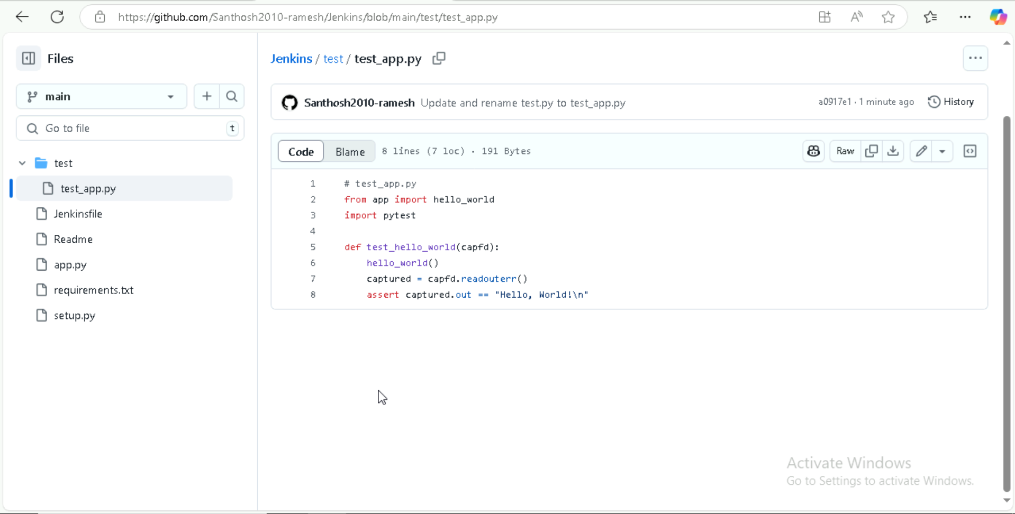

**Step 6: Build and Archive Artifacts with Declarative: Checkout SCM, Clone Repository, set up Virtual Environment, Install Dependencies, Run Tests, Build Artifact, Archive Artifact.**

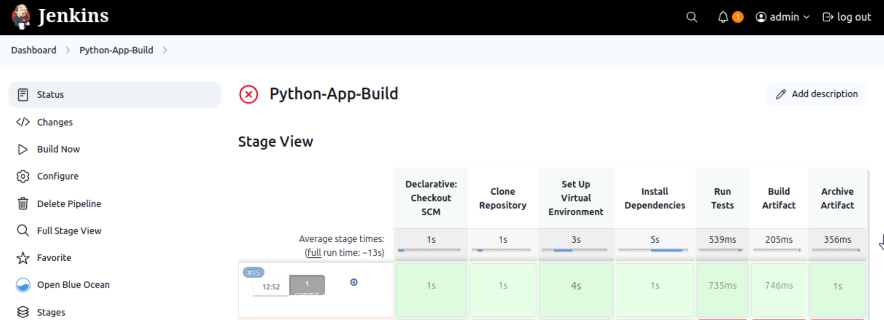

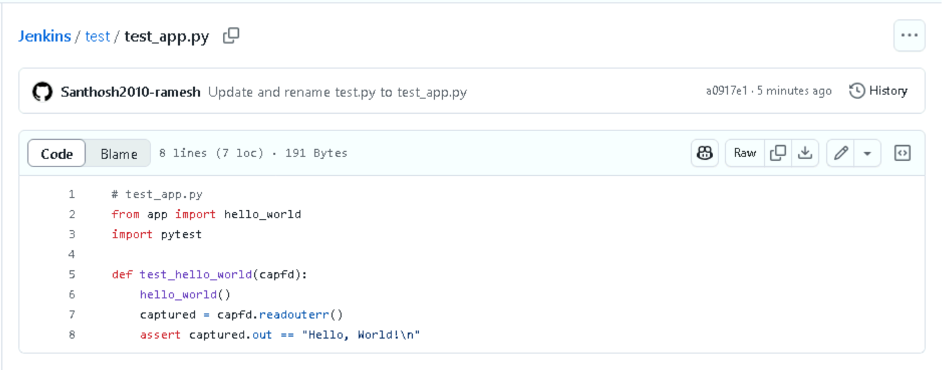

**Step 7: Run the Jenkins Job**

1. Click **Build Now** to trigger a build.
2. Monitor logs in **Console Output**.

